**Power & Structural System Write Up & Validation**

**Power System Overview**

DC-DC Boost Converter

Micro-controller Load

H-Bridge

Artificial Muscle Load

Battery

Figure: Power System Block Diagram

Power Requirements

Microcontroller: 20mA x 10 I/O pins = 0.2Ah @ 7-12V

Artificial Muscle: 0.65-0.7Ah @ 12V

Total: ~0.9 – 1Ah @ 12V

The power system consists of portable LiPo battery, a DC-DC boost converter to convert the varying voltage coming from the battery into a stable voltage useable by the other subsystems, and an H-bridge to control the current the flows across the artificial muscle.

**Battery**

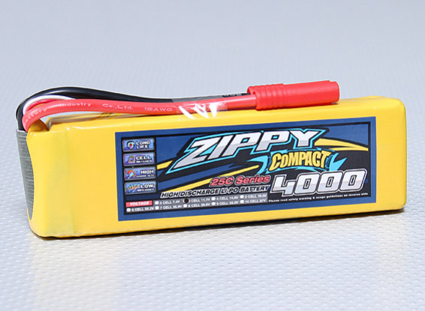1st Iteration:

3-cell (11.1V) 4000mAh LiPo

Safer than Li-Ion (lower chance to leak)

Stores less power than Li-Ion (ok because relatively less power requirement)

Current:

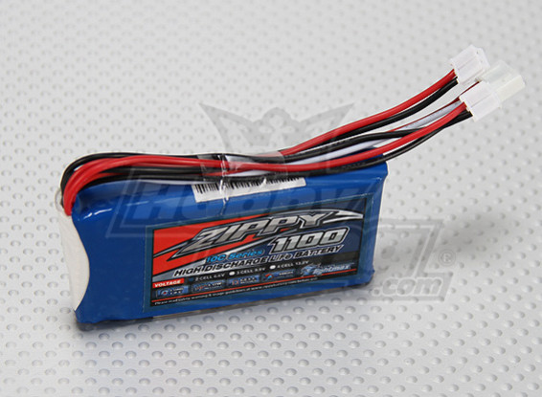2-cell (6.6V) 1100mAh LiFePo4

During converter design found boost converter to be easier to design than a buck-boost converter

Safer than LiPo (no combustion from self-heating – 60 degrees Celsius)

Smaller model but less power (still falls within requirements)

Cheap - $5 battery, ok to replace

Our battery had to go through a few iterations due to a few changes in the power requirements as well as the function of a boost converter vs a buck-boost converter. When designing the DC-DC converter, we found that using a 2-cell LiPo with a voltage range of 6V-8.4V would cause for an easier design and smaller footprint compared to the 3-cell LiPo we had previously selected which would operate over a voltage range of 9V-12.6V and would call for a buck-boost converter design.

**DC-DC Boost Converter**

IC: TPS61088 10A Fully-Integrated Synchronous Boost Converter

Input Voltage: 2.7-12V

Output Voltage: 4.5-12.6V

Output Current: 2A

Pulse-Frequency Modulation (light load) to use Vin to Vout ratio to predict off time switching cycle.

The TPS61088 was chosen primarily due to the integrated PFM feedback which predicts the duty cycle/switching frequency for the converter due to the ratio of Vin to Vout.

Design

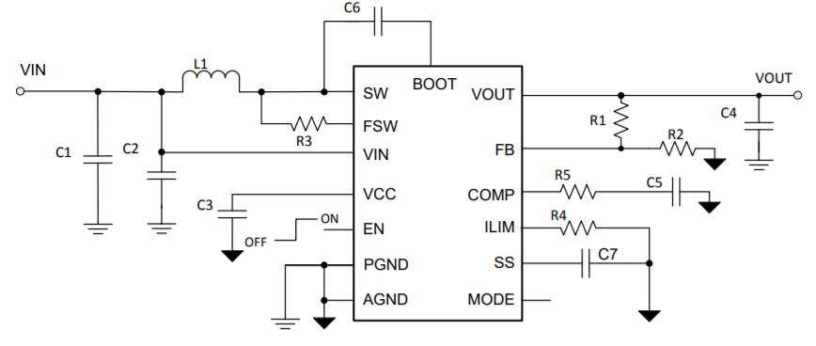

Figure: DC-DC Converter Design

Where:

|  |  |  |  |
| --- | --- | --- | --- |
| C1 = | 22 uF | R1 = | 825 kΩ |
| C2 = | 100 nF | R2 = | 92 kΩ |
| C3 = | 1 uF | R3 = | 261 kΩ |
| C4 = | 22 uF | R4 = | 137 kΩ |
| C5 = | 560 pF | R5 = | 36.5 kΩ |
| C6 = | 100 nF | L1 = | 1.5 uH |
| C7 = | 8.2 nF |  |  |

Table: DC-DC Converter Design Values

The components for the DC-DC boost converter design was based off of the following design equations:

Setting Switching Frequency Minimum 595.681 kHz

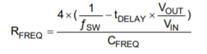 RFREQ = R3

Switching frequency will change according to Vout and Vin ratio, affecting duty cycle. The minimum switching frequency is set by R3 which I chose to be 595.68 kHz as it was listed as an average for most applications. The CFREQ and tDELAY were given within the parameters of the IC. Vin was given as 6V as this is the expected minimum voltage the power system will experience.

Setting Output Voltage using Voltage Divider

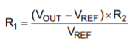

VREF = 1.212 V (given), R2 = 92 kΩ (given)

The output voltage is set by an external resistor voltage divider with R2 being given as a standard for most applications. VREF is given within the operating parameters of the IC.

Inductor Selection

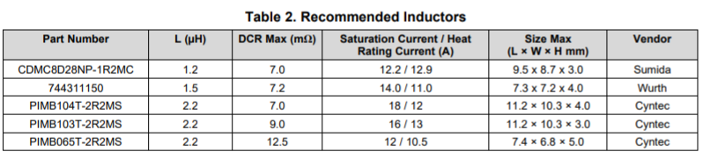

Table: TI Recommended Inductors

The inductor for the converter system was selected according to the above table in respect to the expected inductor current, peak-to-peak ripple, as well as the maximum current peak that could be expected. These parameters were calculated using the following equations:

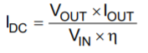 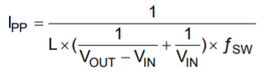 

The other capacitors and resistors throughout the design are used to determine the peak current limit (R4), input voltage filtering (C1), output voltage ripple (C4), as well as the loop stability for the feedback loop (R5, C5, C7). The standard/recommended values listed within the IC datasheet were used for these parameters.

Validation

The validation for this system is based on important simulated expected outputs and function values. These are validated in the following three graphs: The change in duty cycle across the expected voltage range. The change in duty cycle across the range of current that could be pulled from the system at different voltage levels. Finally, the expected efficiency of the converter across the range of expected currents at different voltage levels.

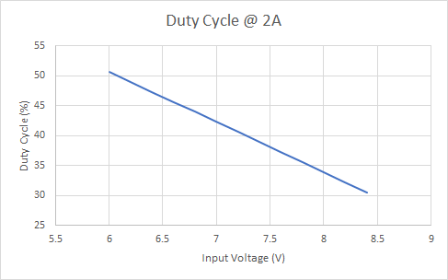

Figure: Duty Cycle vs Input Voltage

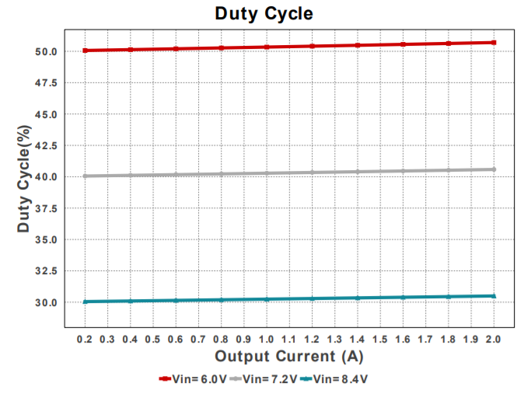

Figure: Duty Cycle vs Current

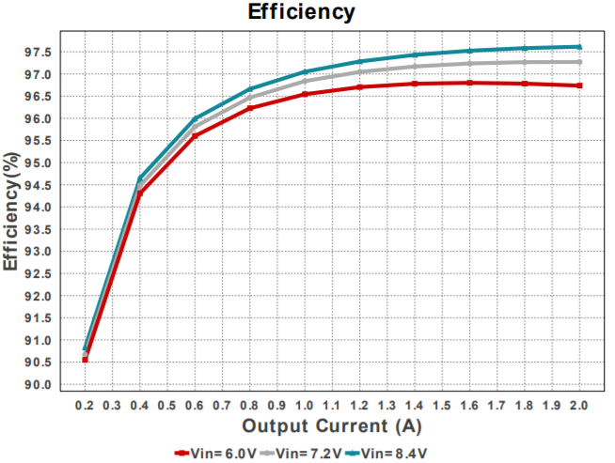

Figure: Power Efficiency vs Current

PCB Design

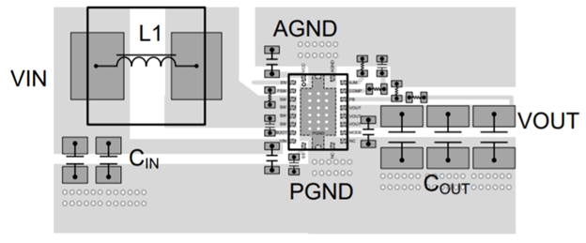

Figure: PCB Layout Example

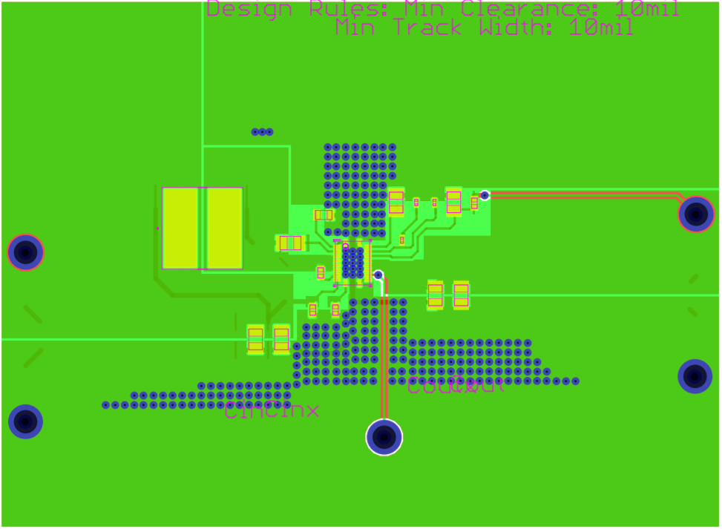

Figure: Eagle Cam File Overlay

The PCB layout was based on the provided recommended layout. The schematic for the DC-DC converter was inserted and the PCB was built using the Eagle CAD software. Below is the finalized overlay of all the CAM file outputs given to the manufacturer.

**H-Bridge**

IC: L293N Quadruple Half-H Drivers

Operating Conditions:

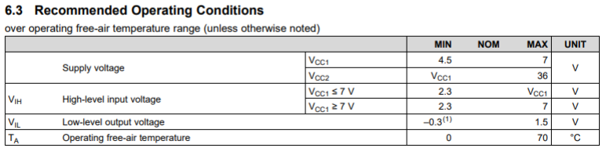 

Table: Operating Conditions

The L293N H-Bridge IC was selected due to the operating conditions falling within the parameters of our system design.

Design

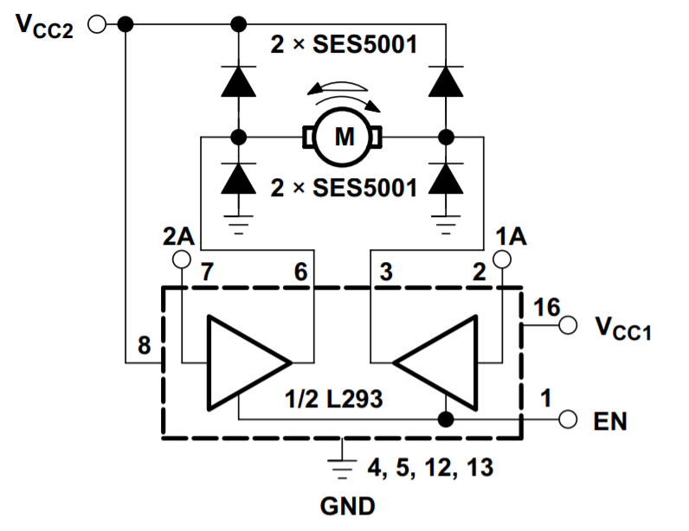

Figure: H-Bridge Design

Using 1 Amp Rectifier Diodes

Truth Table

|  |  |  |  |
| --- | --- | --- | --- |
| EN (Pin 1) | 1A (Pin 2) | 2A (Pin 7) | Function |
| 1 | 0 | 1 | Positive Current |
| 1 | 1 | 0 | Negative Current |
| 1 | 0 | 0 | No Current |

Table: H-Bridge Truth Table

This truth table represents the input values required to achieve the required functions for the Artificial Muscle. These functions are a positive current for a pushing movement, negative current for a retracting movement, as well as no current for no movement of the Artificial Muscle.

Validation

The validation for this system is based on the simulated inputs vs outputs that the H-Bridge is expected to perform based on the inputs given by the microcontroller. These inputs and outputs follow the truth table required for correct operation

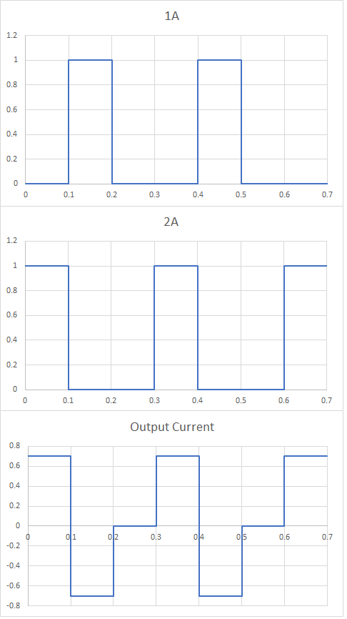

Voltage

Voltage

Current

Time

Figure: H-Bridge Function Generator

**Structural System**

1st Iteration:

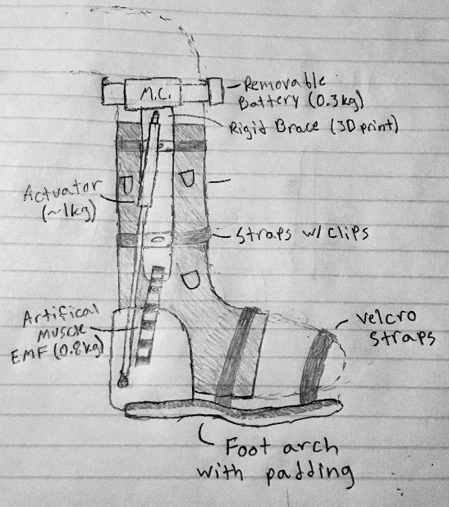

Features: Rigid brace for physical support, Foot arch for natural arch during rehabilitation, Velcro straps and straps with clips for “one size fits all” adjustability, Soft support to hold EMG sensors in place.

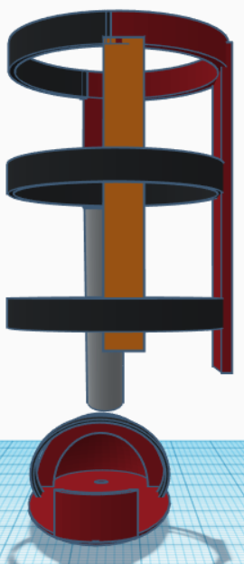

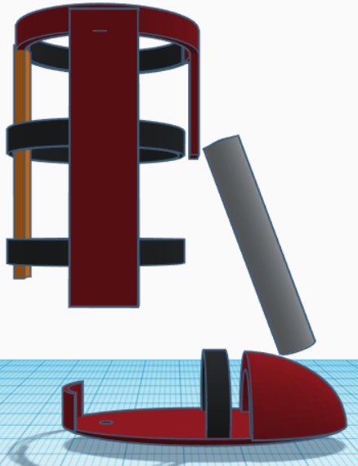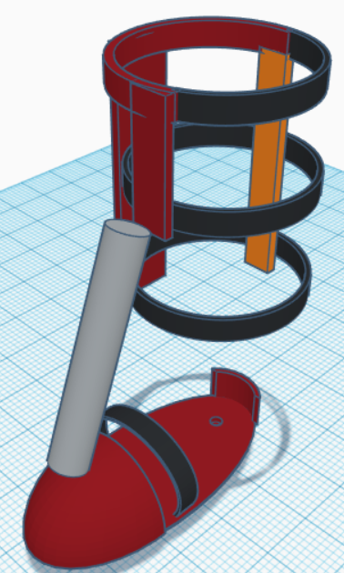Current:

Back View

Side View

Angle View

Legend:

Maroon – Rigid Material (longest piece will hold power system, sensor system, and microcontroller)

Orange – Soft Material (to be used as support for back of calf in conjuction with straps)

Black – Straps with clips

Gray – Artificial Muscle

Will still use a soft support to hold EMG sensors in place, may require a material that dissipates EM waves.

Dimensions based on 18” lower leg/calf length and foot size 10 ½” x 3 ½”.